CHAPTER 9: RELATIONAL DATABASE DESIGN BY ER- AND EER-TO-RELATIONAL MAPPING

Answers to Selected Exercises

9.3 - Try to map the relational schema of Figure 6.14 into an ER schema. This is part of
a process known as reverse engineering, where a conceptual schema is created for
an existing implemented database. State any assumptions you make.

Answer:

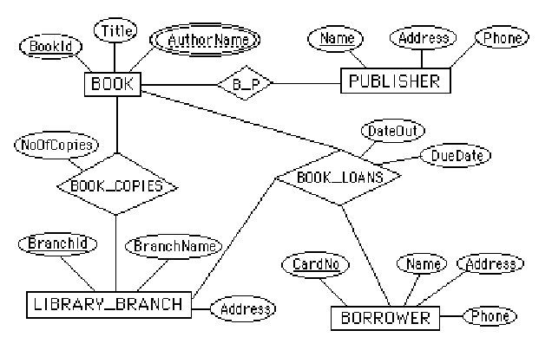

Note: We represented BOOK_AUTHORS as a multi-valued attribute of BOOK in the above
ER diagram. Alternatively, it can be represented as a weak entity type.

9.4 - Figure 9.8 shows an ER schema for a database that may be used to keep track of
transport ships and their locations for maritime authorities. Map this schema into
a relational schema, and specify all primary keys and foreign keys.

Answer:

SHIP
SNAME OWNER TYPE PNAME
SHIP_TYPE
TYPE TONNAGE HULL
STATE_COUNTRY
NAME CONTINENT
SEAOCEANLAKE
NAME
SHIP_MOVEMENT
SSNAME DATE TIME LONGITUDE LATITUTE
PORT
S_C_NAME PNAME S_O_L_NAME
VISIT
VSNAME VPNAME STARTDATE ENDDATE
f.k.
f.k.
f.k. f.k. f.k.
f.k.
f.k.

9.5 Map the BANK ER schema of Exercise 7.23 (shown in Figure 7.21) into a relational schema. Specify all primary keys and foreign keys. Repeat for the AIRLINE schema (Figure 7.20) of Exercise 7.19 and for the other schemas for Exercises 7.16 through 7.24.

Partial Answer:

BANK
CODE NAME ADDR
ACCOUNT
ACCTNO BALANCE TYPE BCODE BNO
CUSTOMER
SSN NAME PHONE ADDR
LOAN
LOANNO AMOUNT TYPE BCODE BNO
BANK_BRANCH
BCODE BRANCHNO ADDR
A_C
SSN ACCTNO
L_C
SSN LOANNO
f.k.
f.k. f.k.
f.k.
f.k. f.k.
f.k.
f.k. f.k.

9.6 – 9.9: No solutions provided.

