1. Explain the reason why the performance of Ethernet LAN decreases with increase in number of stations on the LAN,whereas it increases with the increase in the number of stations in token ring LAN?

ANS: In Ethernet configuration, as number of stations increase, collision increases and stations have to abort transmission and try again. Thus utilization / performance decreases. In Token Ring configuration, when token is passed from one station to the next, the time it takes to travel is simply overhead. As number of stations increase, time to travel between adjacent stations is less, thus improving the utilization / performance of the LAN.

1. What are the basic network node components?

Hub, Bridges, Remote bridges, Routers, Gateways, Half bridge / half router, Switches, Transport devices (ADM, SDH), Broadband access components, Residential distribution devices.

ANS:



1. What are the OSI Network Management Model

* Organization
  + Network management components
  + Functions of components
  + Relationships
* Information
  + Structure of management information (SMI)
    - Syntax and semantics
  + Management information base (MIB)
    - Organization of management information
  + Object-oriented
* Communication
  + Transfer syntax with bidirectional messages
  + Transfer structure (PDU)
* Functions
  + Application functions
    - Configure components
    - Monitor components
    - Measure performance
    - Secure information
    - Usage accounting

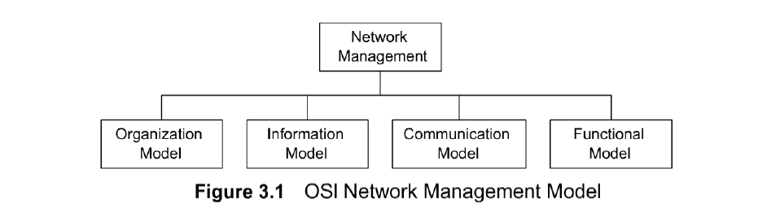

1. What are the **SNMP** Model

* Organization Model
  + Relationship between network element,  
     agent, and manager
  + Hierarchical architecture
* Information Model
  + Uses ASN.1 syntax
  + SMI (Structure of Management Information)
  + MIB ( Management Information Base)
* Communication Model
  + Transfer syntax
  + SNMP over TCP/IP
  + Communication services addressed by messages
  + Security framework community-based model
* Functions
  + Application functions
    - Fault management
    - Configuration management
    - Account management
    - Performance management
    - Security management

1. What are application Function In **SNMP** ( functional )?

* Configuration management
  + Set and change network configuration component parameters
  + Set up alarm thresholds
* Fault management
  + Detection and isolation of failures in network
  + Trouble ticket administration
* Performance management
  + Monitor performance of network
* Security management
  + Authentication
  + Authorization
  + Encryption
* Accounting management
  + Functional accounting of network usage

1. What are organization related to **SNMP** ( organizational )?

* Manager

Sends requests to agents

Monitors alarms

Houses applications

Provides user interface

* Agent

Gathers information from objects

Configures parameters of objects

Responds to managers’ requests

Generates alarms and sends them to managers

* Managed object

Network element that is managed

Houses management agent

All objects are not managed / manageable

1. Explain the Tow-Tier NM Organization Model

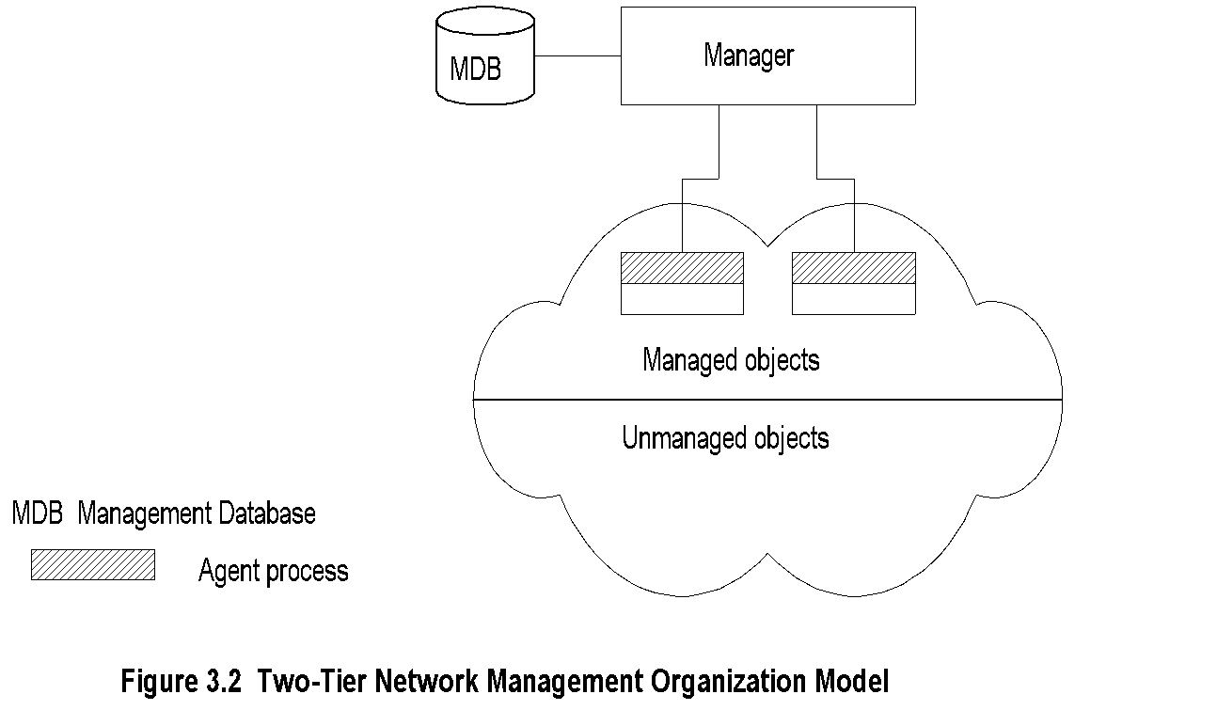

* Agent built into network element Example: Managed hub, managed router
* An agent can manage multiple elements Example: Switched hub, ATM switch
* MDB is a physical database
* Unmanaged objects are network elements that are not managed - both physical (unmanaged hub) and logical (passive elements)

1. Explain the Three-Tier NM Organization Model

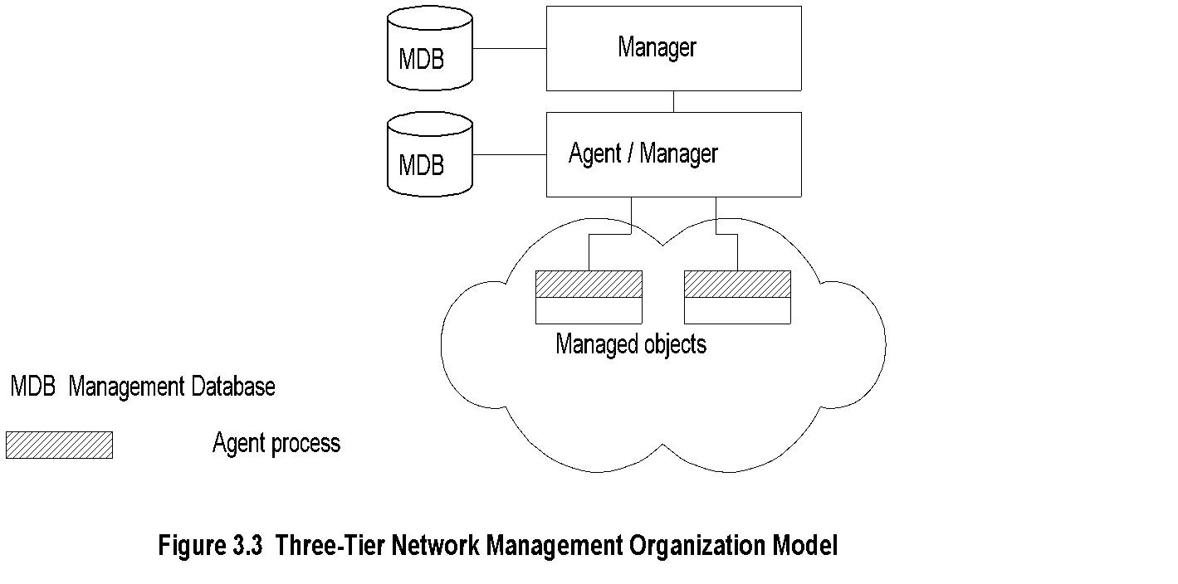

* Middle layer plays the dual role
  + Agent to the top-level manager
  + Manager to the managed objects
* Example of middle level: Remote monitoring  
   agent (RMON)

1. What are the different between Request and response in Management and Communication Module ?

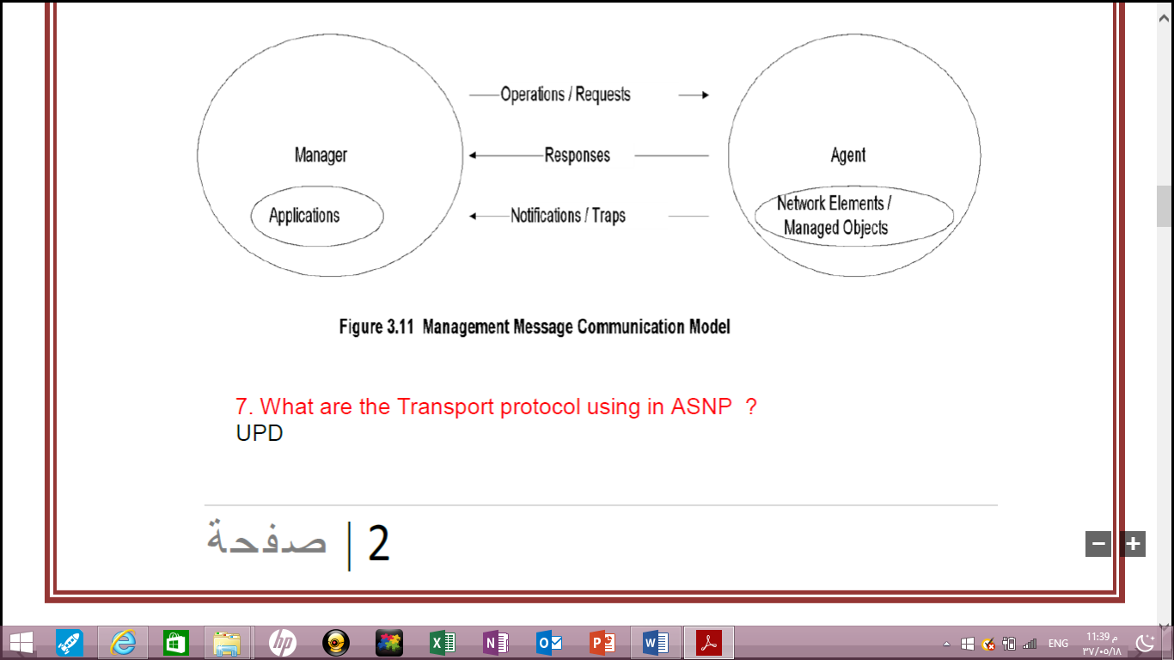

* In Internet requests/responses, in OSI operations
* In Internet traps and notifications (SNMPv2), in   
   OSI notifications

1. **Management Data Base / Information Base**

* Distinction between MDB and MIB
  + MDB physical database; e.g., Oracle, Sybase
  + MIB virtual database; schema compiled into  
     management software.
* An NMS can automatically discover a managed  
   object, such as a hub, when added to the network
* The NMS can identify the new object as hub only  
   after the MIB schema of the hub is compiled into  
   NMS software

1. What are the Transport protocol using in?

UDP is connectionless transport protocol and   
 provides datagram service

1. Explain the Three-Tier Organization Model (RMON).

Answer

* Managed object comprises network element and management agent
* RMON acts as an agent and a manager
* RMON (Remote Monitoring) gathers data from MO, analyses the data, and stores the data
* Communicates the statistics to the manager

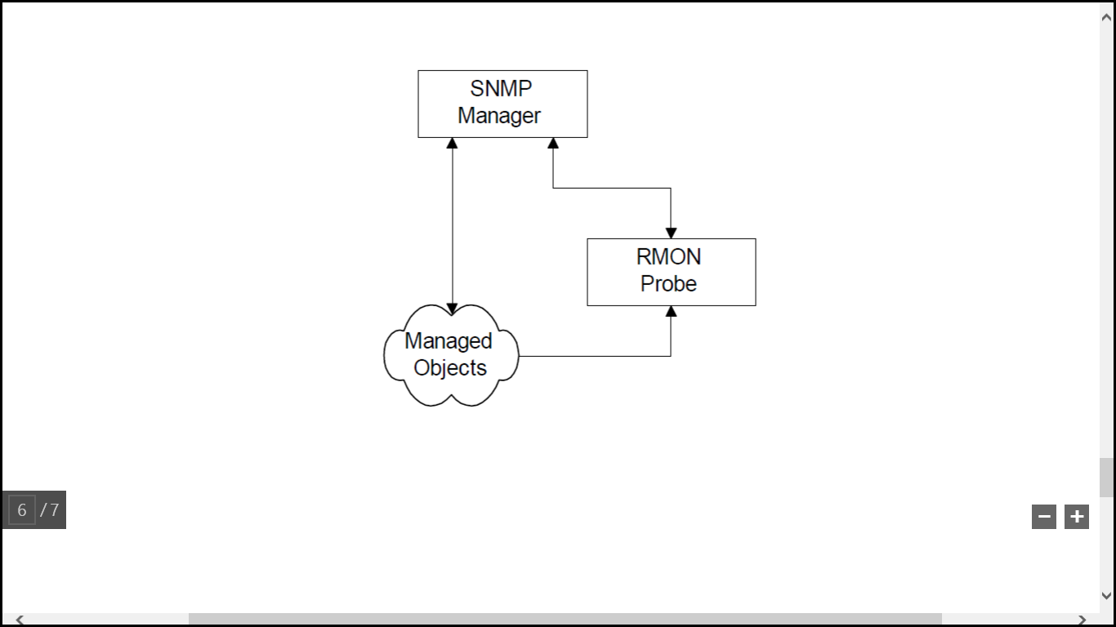

1. Explain the Three-Tier Organization Model (with proxy).

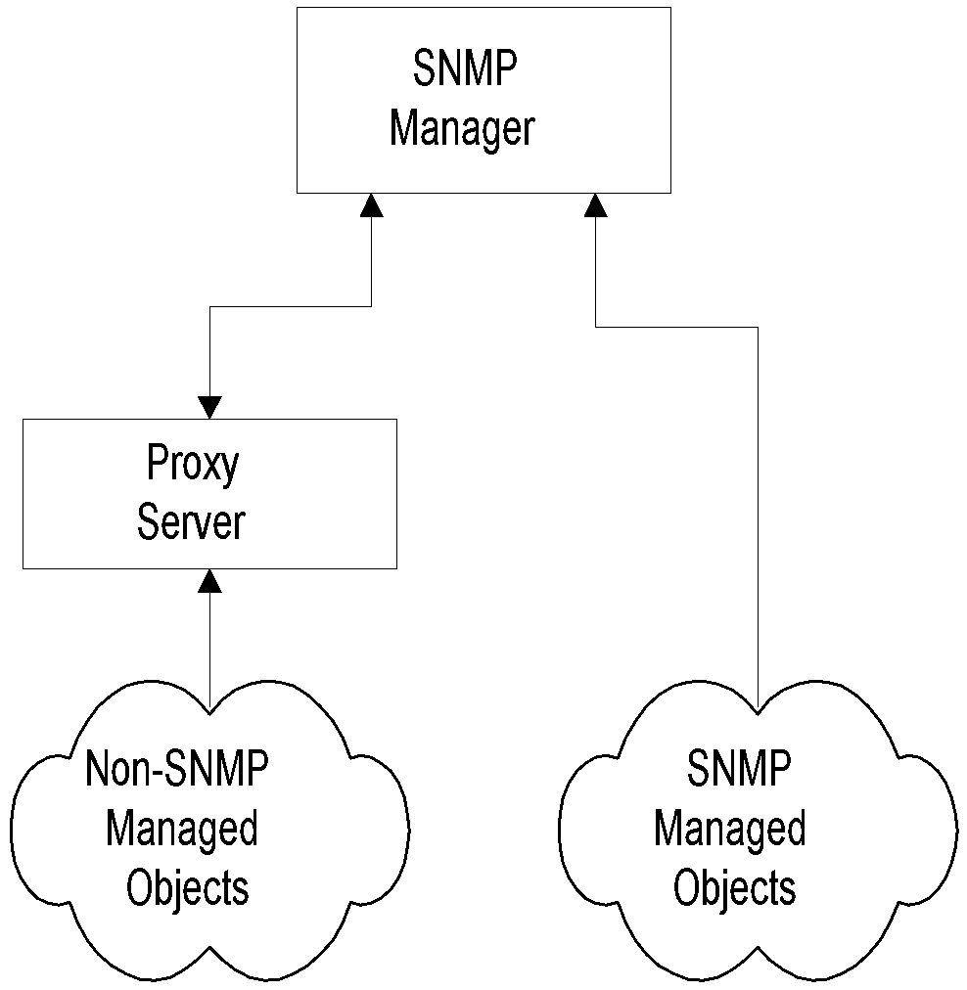

* Proxy server converts non-SNMP data from non-SNMP objects to SNMP compatible objects and messages

1. List three factors that can influence the choice of whether to implement a peer-to-peer or server-based network configuration.

Three factors that can influence the choice of whether to implement a peer-to-peer or server-based network configuration are 1. the size of the organization, 2. the level of security required, and 3. the type of business being conducted.

1. **What are SNMP Messages** or What are the five message Request in SNMP Messages ?

* Get-Request
  + Sent by manager requesting data from agent
* Get-Next-Request
  + Sent by manager requesting data on the next  
     MO to the one specified
* Set-Request
  + Initializes or changes the value of network  
     element
* Get-Response
  + Agent responds with data for get and set   
     requests from the manager
* Trap
  + Alarm generated by an agent

1. List any 3 SNMP v1 Messages. Briefly explain any two of them.

• Get-Request

• Get-Next-Request

• Set-Request

• Get-Response

• Trap

* Generic trap
  + coldStart
  + warmStart
  + linkDown
  + linkUp
  + authenticationfailure
  + egpNeighborLoss
  + enterpriseSpecific
* Specific trap
  + For special measurements such as statistics
* Time stamp: Time since last initialization

1. What is used of Community name?

It used as Password or Authentication between agent and manager.

1. What is role of Trap ?

To notify the Manager

1. **SNMPv2 New Messages**

* inform-request
  + manager-to-manager message
* get-bulk-request
  + transfer of large data
* report
  + not used

1. What is the form of ASNMP operation ?

* Retrieving Data - GET, GETNEXT, WALK, GETBULK
* Altering Variables - SET
* Receiving Unsolicited Messages - Traps and INFORMS
* get
* get-next
* get-bulk (SNMPv2 and SNMPv3)
* set
* get-response
* trap
* notification (SNMPv2 and SNMPv3)
* inform (SNMPv2 and SNMPv3)
* report (SNMPv2 and SNMPv3)

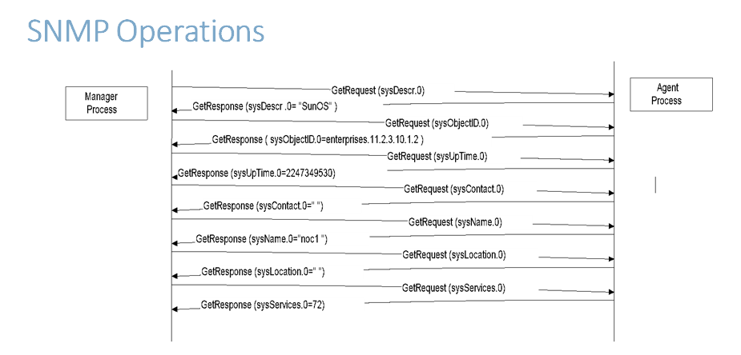

1. How to read MIB Lexicographic order?

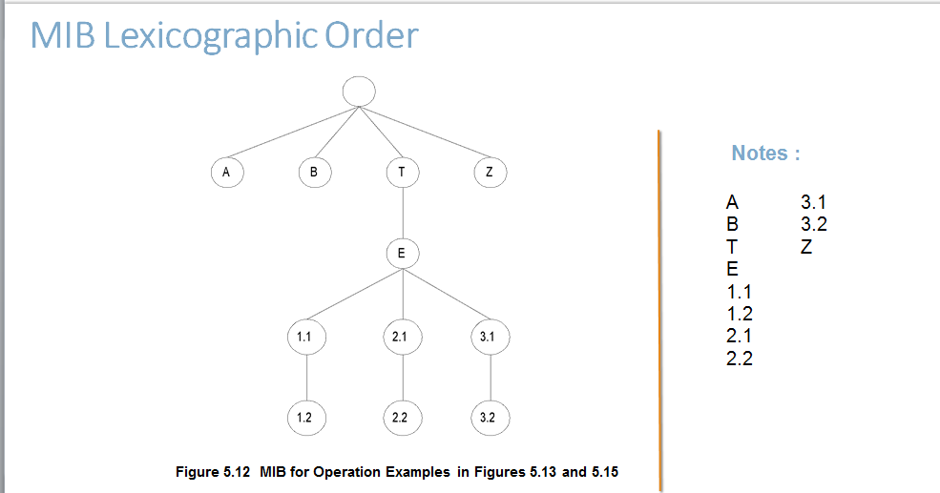

1. Components of the architecture of SNMP ?

* Management Information Base (MIB)
* SNMP Agent
* Network Management System (NMS)
* Structure of Management Information (SMI)
* messages between mangers and agent

1. What does the communication model specifies ?

The SNMPvI communication model defines specifications of four aspects of SNMP communication: architecture, administrative model that defines data access policy, SNMP protocol, and SNMP MIB.

1. what are RMON benefits?

1. Monitors and analyzes locally and relays data; Less load on the network

2. Needs no direct visibility by NMS; More reliable information

3. Permits monitoring on a more frequent basis and hence faster fault diagnosis

4. Increases productivity for administrators

1. what is the **Ping ?**

* Most basic tool for internet management
* Based on ICMP ECHO_REQUEST message
* Available on all TCP/IP stacks
* Useful for measuring connectivity
* Useful for measuring packet loss
* Can do autodiscovery of TCP/IP equipped stations   
   on single segment